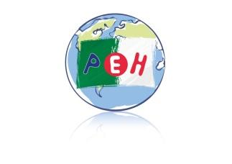
EFFECTIFS ELEVES
2021 / 2024

Petite Ecole d’Hydra
ALGER

Niveaux  Années | TPS | PS | MS | GS | CP | CE1 | CE2 | CM1 | CM2 | TOTAUX
2021/2022 | 5 | 8 | 12 | 20 | 23 | 21 | 21 | 17 | 15 | 142
2022/2023 | 2 | 10 | 19 | 21 | 15 | 16 | 20 | 16 | 22 | 141
2023/2024 | 1 | 12  (-1 +2) | 12 | 26  (-1 +1) | 29 | 24 | 28 | 25 | 24 | 181
Répartition  Classes  2023/2024 | TPS/PS/MS |  | GS | CP1 | CP2 | CE1 | CE2 | CM1 | CM2 | 8 classes
 | 25 |  | 26 | 14 | 15 | 24 | 28 | 25 | 24 | 181

